**Pertemuan 9: Framework I**

**Tugas 9 : Membuat Project Laravel Dan CRUD**

|  |  |
| --- | --- |
| **Nama / Nim** | **: Indratma Rakha Putra (2218129)** |
| **Kelas** | **: H** |
| **Pengajar** | **:** **AHMAD RIZKY RAMADHANI (2218103)** |

* 1. **Tujuan**

1. Mampu memahami konsep MVC pada framework Laravel.
2. Mampu mengkofiguransi framework Laravel.
   1. **Alat dan Bahan**
3. Laptop/pc
4. Modul Praktikum Web 2024
5. TextEditor (Visual Studio Code / Sublime Text)
   1. **Langkah-langkah**
6. Mengubah CRUD Memakai Laravel

Source code 2024_06_09_053903_create_music_table.php:

|  |
| --- |
| <?php  use Illuminate\Database\Migrations\Migration;  use Illuminate\Database\Schema\Blueprint;  use Illuminate\Support\Facades\Schema;  class CreateMusicsTable extends Migration  {      /**       * Run the migrations.       *       * @return void       */      public function up()      {          Schema::create('musics', function (Blueprint $table) {              $table->id();              $table->string('artis');              $table->string('judul');              $table->string('album');              $table->date('rilis');              $table->timestamps();          });      }      /**       * Reverse the migrations.       *       * @return void       */      public function down()      {          Schema::dropIfExists('musics');      }  } |

Source code model Music.php:

|  |
| --- |
| <?php  namespace App\Models;  use Illuminate\Database\Eloquent\Factories\HasFactory;  use Illuminate\Database\Eloquent\Model;  class Music extends Model  {      use HasFactory;      protected $fillable = [          'artis',          'judul',          'album',          'rilis'      ];      protected $table = 'musics';  } |

Source code controller MusicController.php:

|  |
| --- |
| <?php  namespace App\Http\Controllers;  use App\Models\Music;  use Illuminate\Http\Request;  class MusicController extends Controller  {      public function index()  {      $musics = Music::all();      return view('music.index', compact('musics'));  }      public function create()      {          return view('Music.create');      }      public function store(Request $request)      {          $request->validate([              'artis' => 'required',              'judul' => 'required',              'album' => 'required',              'rilis' => 'required|date',          ]);          Music::create($request->all());          return redirect()->route('music.index')->with('success', 'Music created successfully.');      }      public function edit(Music $music)      {          return view('music.edit', compact('music'));      }      public function update(Request $request, Music $music)  {      $request->validate([          'artis' => 'required',          'judul' => 'required',          'album' => 'required',          'rilis' => 'required|date',      ]);      $music->update($request->all());      return redirect()->route('music.index')->with('success', 'Music updated successfully.');  }  public function destroy(Music $music)  {      $music->delete();      return redirect()->route('music.index')->with('success', 'Music deleted successfully.');  }  } |

Source code difolder route web.php:

|  |
| --- |
| <?php  use Illuminate\Support\Facades\Route;  use App\Http\Controllers\MusicController;  Route::resource('music', MusicController::class); |

1. Data Dokter Di Project Laravel

Source code difolder layout app.blade.php:

|  |
| --- |
| <!DOCTYPE html>  <html lang="en">  <head>      <meta charset="UTF-8">      <meta name="viewport" content="width=device-width, initial-scale=1.0">      <title>Music App</title>      <link rel="stylesheet" href="https://maxcdn.bootstrapcdn.com/bootstrap/4.0.0/css/bootstrap.min.css">  </head>  <body>      <nav class="navbar navbar-expand-lg navbar-light bg-light">          <a class="navbar-brand" href="#">Music App</a>          <div class="collapse navbar-collapse">              <ul class="navbar-nav mr-auto">                  <li class="nav-item">                      <a class="nav-link" href="{{ route('music.index') }}">Home</a>                  </li>              </ul>          </div>      </nav>      <div class="container mt-4">          @yield('content')      </div>  </body>  </html> |

Source code difolder Pelayanan index.blade.php:

|  |
| --- |
| @extends('layouts.app')  @section('content')      <h1>Manage Layanan</h1>      <button class="btn btn-primary" data-toggle="modal" data-target="#createModal">Create</button>      <h2>All Layanan</h2>      <table>          <thead>              <tr>                  <th>ID Layanan</th>                  <th>Jenis Layanan</th>                  <th>Harga</th>                  <th>Baby Sitter</th>                  <th>Action</th>              </tr>          </thead>          <tbody>              @foreach($Pelayanan as $Pelayanan)                  <tr>                      <td>{{ $Pelayanan->id }}</td>                      <td>{{ $Pelayanan->jenis_layanan }}</td>                      <td>{{ $Pelayanan->harga }}</td>                      <td>{{ $Pelayanan->baby_sitter }}</td>                      <td>                          <button class="btn btn-warning" data-toggle="modal" data-target="#updateModal" onclick="fillForm('{{ $Pelayanan->id }}', '{{ $Pelayanan->jenis_layanan }}', '{{ $Pelayanan->harga }}', '{{ $Pelayanan->baby_sitter }}')">Edit</button>                          <button class="btn btn-danger" data-toggle="modal" data-target="#deleteModal" onclick="deleteForm('{{ $Pelayanan->id }}')">Delete</button>                      </td>                  </tr>              @endforeach          </tbody>      </table>      <!-- Create Modal -->      @include('Pelayanan.create')      <!-- Update Modal -->      @include('Pelayanan.update')      <!-- Delete Modal -->      @include('Pelayanan.delete')  @endsection |

Hasil Tampilan :

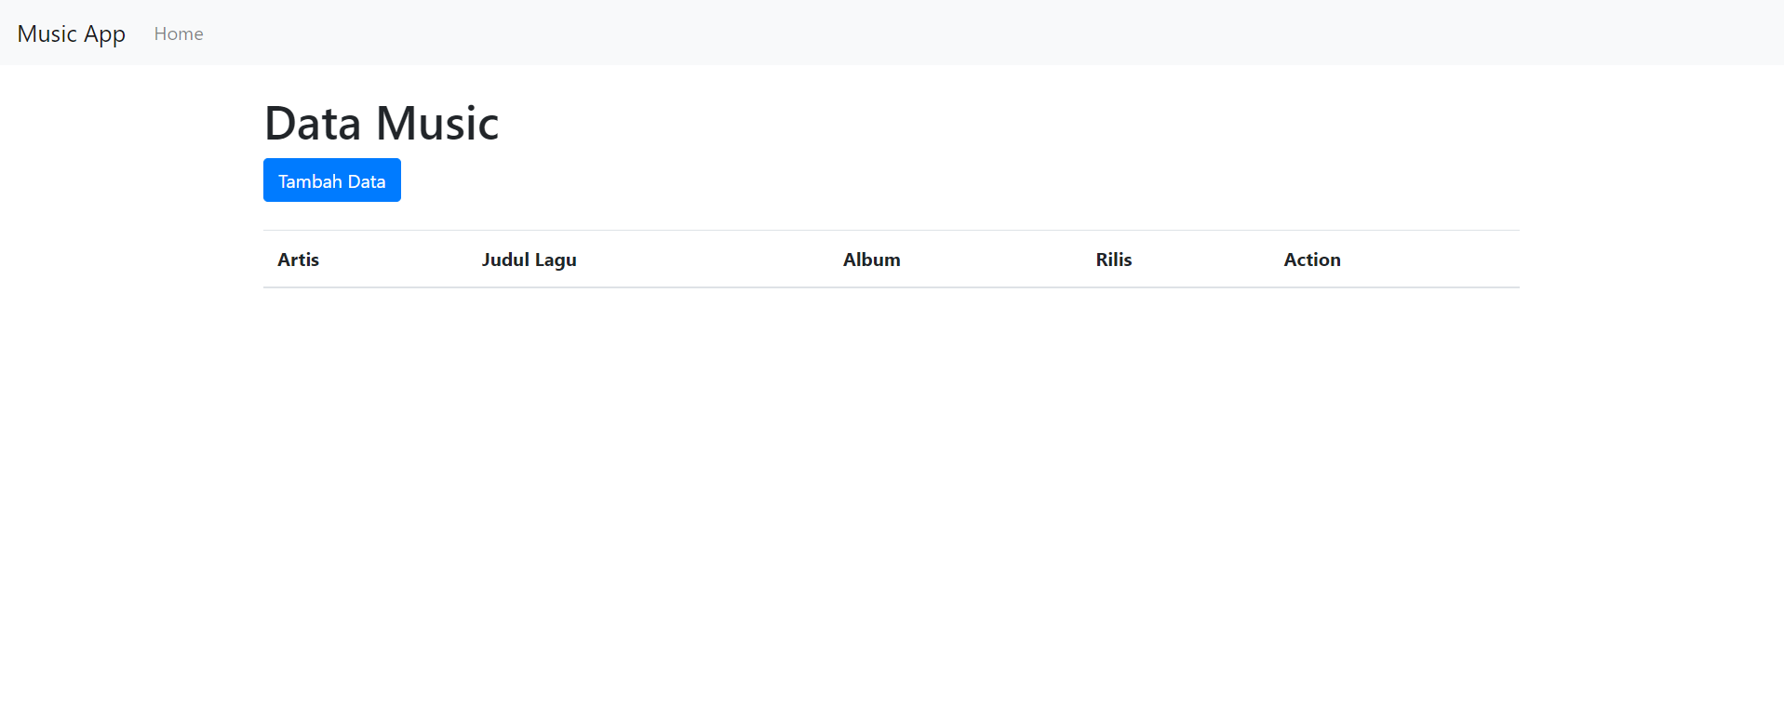

Gambar 8.1 Tampilan Data layanan

1. Entry Data Dokter Di Project Laravel

Source code difolder Music create.blade.php:

|  |
| --- |
| @extends('layouts.app')  @section('content')  <div class="container">      <h1>Tambah Data Music</h1>      <form action="{{ route('music.store') }}" method="POST">          @csrf          <div class="mb-3">              <label for="artis" class="form-label">Artis</label>              <input type="text" class="form-control" id="artis" name="artis" required>          </div>          <div class="mb-3">              <label for="judul" class="form-label">Judul</label>              <input type="text" class="form-control" id="judul" name="judul" required>          </div>          <div class="mb-3">              <label for="album" class="form-label">Album</label>              <input type="text" class="form-control" id="album" name="album" required>          </div>          <div class="mb-3">              <label for="rilis" class="form-label">Rilis</label>              <input type="date" class="form-control" id="rilis" name="rilis" required>          </div>          <button type="submit" class="btn btn-primary">Simpan</button>      </form>  </div>  @endsection |

Hasil Tampilan :

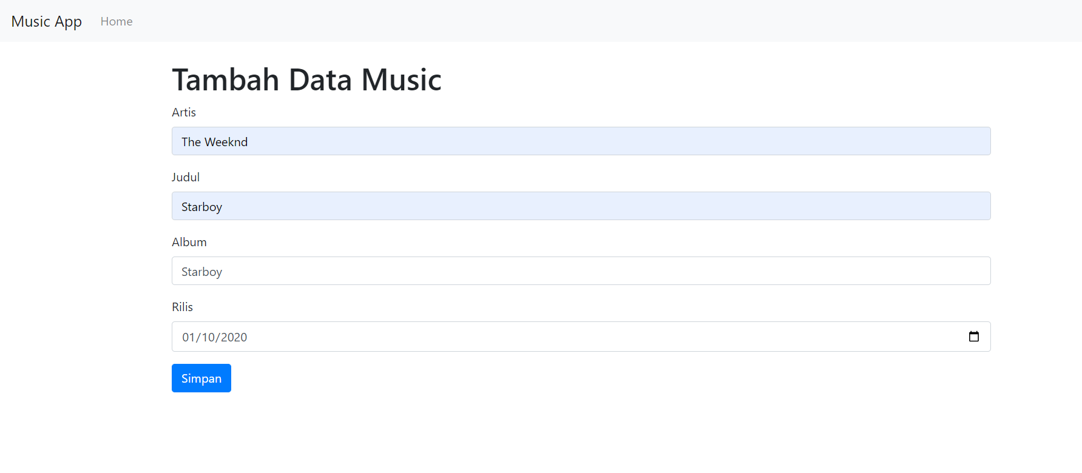

Gambar 8.2 Tampilan Entry Data Music

1. Edit Data Dokter Di Project Laravel

Source code difolder Music edit.blade.php:

|  |
| --- |
| @extends('layouts.app')  @section('content')  <div class="container">      <h1>Edit Data Music</h1>      <form action="{{ route('music.update', $music->id) }}" method="POST">          @csrf          @method('PUT')          <div class="mb-3">              <label for="artis" class="form-label">Artis</label>              <input type="text" class="form-control" id="artis" name="artis" value="{{ $music->artis }}" required>          </div>          <div class="mb-3">              <label for="judul" class="form-label">Judul</label>              <input type="text" class="form-control" id="judul" name="judul" value="{{ $music->judul }}" required>          </div>          <div class="mb-3">              <label for="album" class="form-label">Album</label>              <input type="text" class="form-control" id="album" name="album" value="{{ $music->album }}" required>          </div>          <div class="mb-3">              <label for="rilis" class="form-label">Rilis</label>              <input type="date" class="form-control" id="rilis" name="rilis" value="{{ $music->rilis }}" required>          </div>          <button type="submit" class="btn btn-primary">Update</button>      </form>  </div>  @endsection |

Hasil Tampilan :

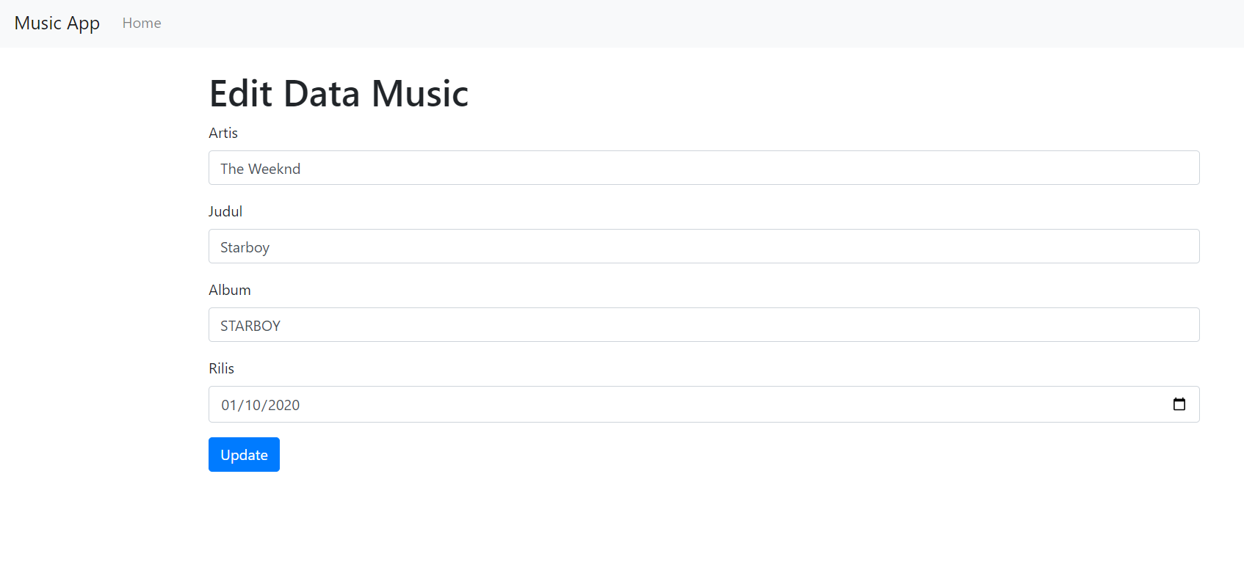

Gambar 8.3 Tampilan Edit Data Item

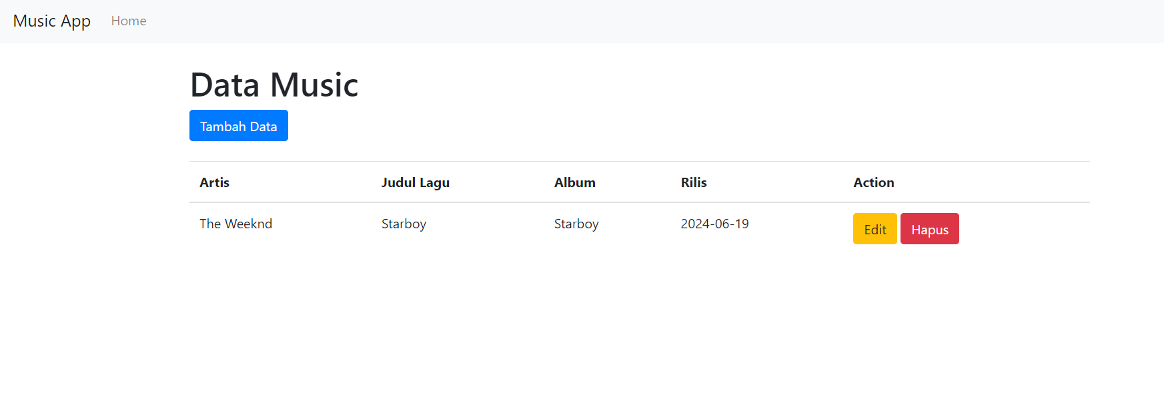

Gambar 8.4 Tampilan Hapus Data Item

Analisa :

Laravel adalah sebuah *framework* untuk mengembangkan aplikasi *web*. Dengan menggunakan *framework* ini, dapat bisa mempercepat waktu pengembangan aplikasi, mempermudah pengelolaan sumber daya dengan performa terbaik, dan mendapatkan aplikasi yang lebih aman dengan OWASP *security* *principles*. Pada *source* *code* diatas diubah dari *php* *native* ke Laravel *framework* yang dikoneksikan dengan tabel yang sudah dibuat.